Windows Navigation Diagram

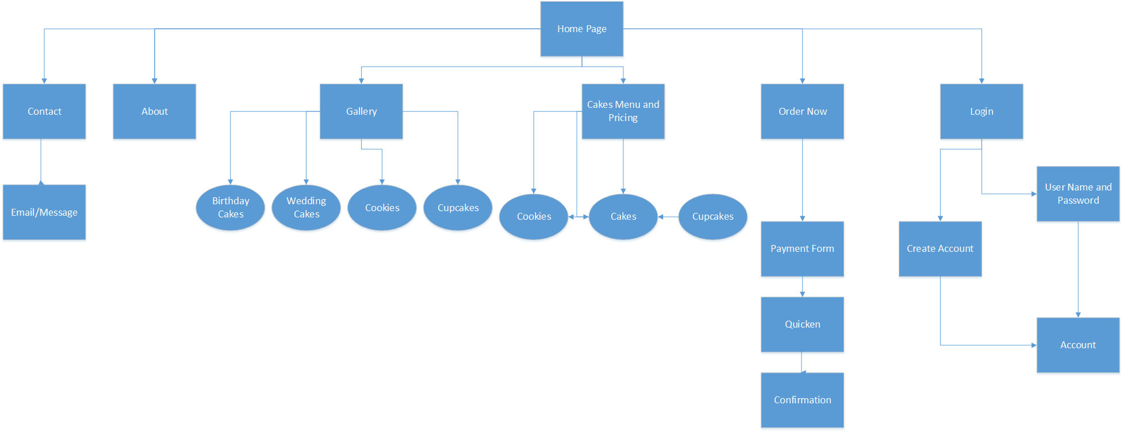

The Windows Navigation Diagram shows the navigation paths between the web pages on Sweet Karoline’s Cakes website. The Home Page is the Starting point of the Diagram because it is the Starting point of Karoline’s website. The home site has links to 6 different web pages. These web pages are (Contact, About, Gallery, Cake’s Menu and Pricing, Order Now, and Login). The contact page links to a page where a customer can message Karoline via Email. The Gallery and the Cake’s Menu and Pricing pages contain links to specific types of items including Birthday cakes, Wedding cakes, Cookies, and Cupcakes. The Order Now page links to the Payment Form which links to Quicken which is Karoline’s accounting system. After the Order is completed a Confirmation page is opened. A customer can login on the Login page or click a link that will take them to the Create Account page. If the user already has an account and login, it will ask the user to input their username and password which will let them enter their Account page.